
School of Science, Computing and Engineering Technologies

Object Oriented Programming
Pass Task 3.3: Drawing Program - A Drawing Class with your own attributes

Overview
In this task, you extend the ShapeDrawer application that you created in “2.3P Drawing Basic Shapes with your own attributes.”

Purpose: Task:
Learn to apply object-oriented programming techniques related to collaboration and the use of framework classes.
Extend the shape drawing program to allow for many shapes to be drawn on the screen. The task contains personalized requirements.

Deadline: Due by the end of week four, Friday, 23 August 2024 (Firmed).

Submission Details
All students have access to the Adobe Acrobat tools. Please print your solution to PDF and combine it with the screenshots taken for this task.
- C# code files of the classes created.
- Screenshot of running program (i.e., SplashKit window).



Instructions
Continue with the ShapeDrawer application that you developed in task 2.3P Drawing Program – A Basic Shape. You may want to archive your previous work before extending the application.
Presently, your program only allows you to draw one shape (i.e., a rectangle at the current mouse pointer position). However, a general drawing program should be able to draw many shapes to the screen. To achieve this, extend your program with a new class, called Drawing. Class Drawing defines a container of Shape objects and provides mechanisms to add shapes to the collection, to select shapes for drawing, to remove shapes from the collection, and to draw the selected shapes to the screen. In addition, class Drawing supports a set of properties to query information about the collection or to alter drawing attributes.

Note: You can probably think of many other operations for the drawing, such as saving to file etc. This will be a useful part of the overall program.
The following UML diagram illustrates the new system design.
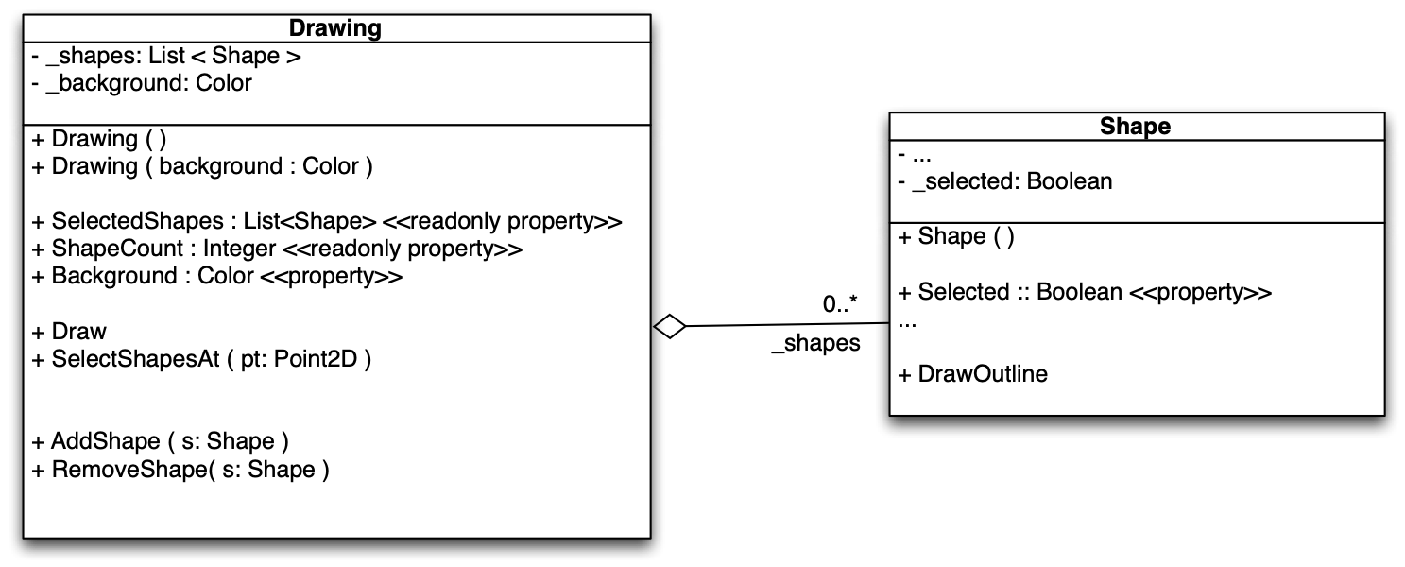
The line between class Drawing and class Shape, with the hollow diamond, indicates an aggre- gation between class Drawing and class Shape. It states that objects of class Drawing have a “_shapes” collection of zero or more objects of class Shape as attribute.

Note: The _shapes field is actually a list of Shape objects, which can have zero of more elements.

- Open your ShapeDrawer solution.
- Add a new class, called Drawing, to your application.
- Add a private, read-only field _shapes. Use List<Shape> as the type for _shapes.

Note: Class List is a member of the System.Collections.Generic namespace. This namespace is implicitly available to every C# project. Hence, you do not need to add a using declaration for this namespace at the top or your C#-class file.

Tip: Mark fields as readonly if you are not going to change them after the object is created. In case of _shapes, we will always be using the same List object, so we do not want to change the field.

Note: A readonly field cannot be changed, meaning that you cannot assign a new value to the field. However, the object that field refers to can change, and will change in this case as we add and remove shapes from the list.

public class Drawing
{
private readonly List<Shape> _shapes;
…
public Drawing(Color background)
{
_shapes = new List<Shape>();
…
}
}

- Add a private _background field and public Background property for the background color. Use type Color as type. You need to add using SplashKitSDK; at the top of your Drawing.cs file to make type Color available.
- Create the constructor that takes in the background color as a parameter.
- Create a new List<Shape> object and assign it to the _shapes field.
- Initialize the _background to the supplied background color.

Object-oriented programming languages come with a rich set of class libraries. These libraries include a set collection classes, like List, that manage collections of objects. Collection classes define the smarts needed to maintain a collections of objects for you. For example, the List class provides the intelligence to manage a dynamic array of objects. You can add, remove, and fetch objects from the list, etc. A List has everything you need if you want a dynamic array of some kind.
In C# and the .NET framework, collection classes are generic datatypes. Generic datatypes provide a uniform set of operations for the objects contained in the collection across all possible instantiations. For example, the specification List<Shape> instantiates the generic type List with class Shape. The result is a list of Shape objects. Generic collections “remember” which type of objects they store. So, if you can add a Shape object to a List<Shape> collection, then you get Shape objects back if you ask the List<Shape> collection to return an element.
- Add a second constructor with no parameters to class Drawing. A constructor with no pa- rameters is called default constructor. Default constructors initializes objects with predefined values.
When defining the default constructor, you want to avoid code duplication. For this reason, you use a this-call to another defined constructor to initialize the object. In case of class Drawing, use the constructor that takes a background color for the this-call, using Color.White as argument.

public class Drawing
{
public Drawing ( Color background ) { … }
public Drawing ( ) : this ( Color.White )
{
// other steps could go here…
}
}

Note: When you use a this-call, all member variables should be initialized in the target constructor. For example, calling new Drawing() must return an object that is equal to an object returned by new Drawing( Color.White ).

- Add a read-only ShapeCount property to class Drawing that returns the Count from the
_shapes list collection object.

Tip: Follow the single responsibility principle (SRP) in your object-oriented design. For example, which actor in your system is responsible for computing the number of objects in _shapes? You do not reimplement this feature in class Drawing. The responsibility rests with class List. So, you ask List to compute its Count and return the result as value for read-only property ShapeCount.
- Create the AddShape method in class Drawing that adds the shape it receives to its list of shapes.
- Create the RemoveShape method in class Drawing that removes the shape it receives from its list of shapes.

Note: List’s Remove method returns true if it successfully removed an item. You may want to use a discard assignment “_ = …” to ignore the return value.
- Switch to your Shape class and add a private _selected field and a public Selected prop- erty. (You do not need to change the constructor. A Boolean field is initialized to false by default.)
- Return to class Drawing and add a Draw method. Tell SplashKit to ClearScreen using the
_background color as argument and then loop over each shape and tell it to Draw itself.

Note: The Drawing class does not actually draw the shapes, it asks the shapes to draw themselves. This is the idea of collaboration in object-oriented programming.
- Go to the Main function in Program.cs.
- Remove the myShape variable and all code referring to myShape.
- Create a Drawing object myDrawing using the default constructor outside the do-while
loop.

- Inside the do-while loop in Main (after SplashKit.ClearScreen):

Note: The do-while loop in Main is also called event loop.
  - Check if the user has clicked the left mouse button. In this case, add a new Shape
to myDrawing using the current mouse pointer location.

Hint: You should use a local variable to create a Shape object using the default construc- tor, then alter the X and Y location of the shape using the mouse pointer location, and finally add the newly created shape to myDrawing.
  - Change the background color of myDrawing to a new random color when the user presses the space bar.
  - Tell myDrawing to Draw before SplashKit.RefreshScreen.
- Compile and run your program. Add shapes and change the background color.
- Switch to class Drawing. Add the SelectShapesAt method to your Drawing class. Use the following pseudocode as a guide.
1:
2:
3:
4:
5:
6:
SelectShapesAt(pt)
// parameter pt is a 2D point
foreach s in _shapes
if Tell s to IsAt(pt) s.Selected := true
else
s.Selected := false

Hint: Avoid the if-statement inside the foreach-loop. The result of IsAt is a Boolean.

- Use the following pseudocode to implement the read-only property SelectedShapes.

SelectedShapes:get()
1: Let result by a new List of Shape objects. 2: foreach s in _shapes
3: if s.Selected
4: Tell result to Add(s) 5: return result

- Switch back to class Shape. Add a DrawOutline method to the Shape class. This method draws a black rectangle around the shape. The black rectangle has to be (5+X) pixels wider on all sides of the shape, where 'X' presents the last digit of your student ID.
- Change the Shape's Draw method add some code to call DrawOutline if the shape is se- lected.
- In function Main, inside the event loop, add an if-statement to check whether the user has clicked the right mouse button. If this is the case, tell myDrawing to SelectShapesAt the current mouse pointer position.
- Compile and run the program and check that you can select shapes
- Adjust the code so that all of the selected shapes are removed from the drawing if the user types the KeyCode.DeleteKey or KeyCode.BackspaceKey. Make sure your work is still con- sistent with the provided UML diagram — you do not need to add anything to class Drawing to make this work!

Note: Make sure to distribute the functionality across the program and class Drawing. The Main program should not interact with the class Drawing's _shapes list directly.

Once your program is complete you can prepare it for your portfolio. This can be placed in your portfolio as evidence of what you have learnt.
- Review your code and ensure it is formatted correctly.
- Run the program and use your preferred screenshot program to take a screenshot of the Terminal showing the program's output.
- Save and backup your work to multiple locations, if possible.
  - Once you your program is working you do not want to lose your work.
  - Work on your computer’s storage device most of the time, but backup your work when you finish each task.
  - You may use a cloud storage provider to safely store your work.
USB and portable hard drives are good secondary backups, but there is a risk that the drive gets damaged or lost.
Once your program is working correctly you can prepare it for your portfolio. Add a screenshot of the program working, and your source code.

Assessment Criteria
Make sure that your task has the following in your submission:
- The “Universal Task Requirements” (see Canvas) have been met.
- Your program (as text or screenshot).
- Screenshots of running program (i.e., SplashKit window) that show the different aspects of the application: add shapes, select shapes, remove shapes, and change background.

namespace ShapeDrawer2
{
internal class Drawing
{
private readonly List<Shape> _shapes;
private Color _background;

public Drawing(Color background)
{
_background = background;
_shapes = new List<Shape>();
}
public Drawing() : this (Color.White)
{

}
public Color Background
{
get
{
return _background;
}
set
{
_background = value;
}
}
public int ShapeCount
{
get
{
return _shapes.Count;
}
}

public void AddShape(Shape shape)
{
if (shape != null)
{
_shapes.Add(shape);
}
}

public void RemoveShape()
{
foreach (Shape _shape in _shapes.ToList())
{
if (_shape.Selected)
{
_shapes.Remove(_shape);
}
}
}

public void Draw()
{

SplashKit.ClearScreen (_background);
foreach (Shape _shape in _shapes)
{

_shape.Draw();
}

}
public void SelectShapesAt(Point2D pt)
{
foreach (Shape _shape in _shapes)
if(_shape.IsAt(pt))
_shape.Selected = true;
else
_shape.Selected = false;
}
public void SelectedShapes()
{
foreach(Shape _shape in _shapes)
if (_shape.Selected)
AddShape( _shape);
return;
}

}
}

public class Shape
{
public Color _color;
public float _x;
public float _y;
public int _width;
public int _height;
public bool _selected;

public Shape(int x, int y)
{
_color = Color.Azure;
_x = x;
_y = y;
_width = 100;
_height = 100;
}
public void Draw()
{
if (Selected)
{
DrawOutline();
}
SplashKit.FillRectangle(_color, _x, _y,
_width, _height);

}
public bool IsAt(Point2D pt)
{
return pt.X >= _x && pt.X <= _x + _width &&
pt.Y >= _y && pt.Y <= _y + _height;
}
public bool Selected
{
get { return _selected; }
set { _selected = value; }
}
public void DrawOutline()
{
SplashKit.FillRectangle(Color.Black, _x -7, _y -7,
_width +14, _height +14);
}

}

public class Program
{
public static void Main()
{
Drawing myDrawing = new Drawing();
Window window = new Window("ShapeDrawer", 800, 600);
SplashKit.MouseClicked(MouseButton.LeftButton);
SplashKit.MouseX();

do
{
SplashKit.ClearScreen();
myDrawing.Draw();
if (SplashKit.MouseClicked(MouseButton.RightButton))
{

myDrawing.SelectShapesAt(SplashKit.MousePosition());
}
if (SplashKit.MouseClicked(MouseButton.LeftButton))
{
int X = (int)SplashKit.MouseX();
int Y = (int)SplashKit.MouseY();
myDrawing.AddShape(new Shape(X, Y));

}
if (SplashKit.KeyTyped(KeyCode.SpaceKey))
{
myDrawing.Background = SplashKit.RandomColor();
}
if (SplashKit.KeyTyped(KeyCode.BackspaceKey))
{
myDrawing.RemoveShape();
}
if (SplashKit.KeyTyped(KeyCode.DeleteKey))
{

myDrawing.RemoveShape();
}

SplashKit.ProcessEvents();
SplashKit.RefreshScreen();
} while (!window.CloseRequested);

}
}

